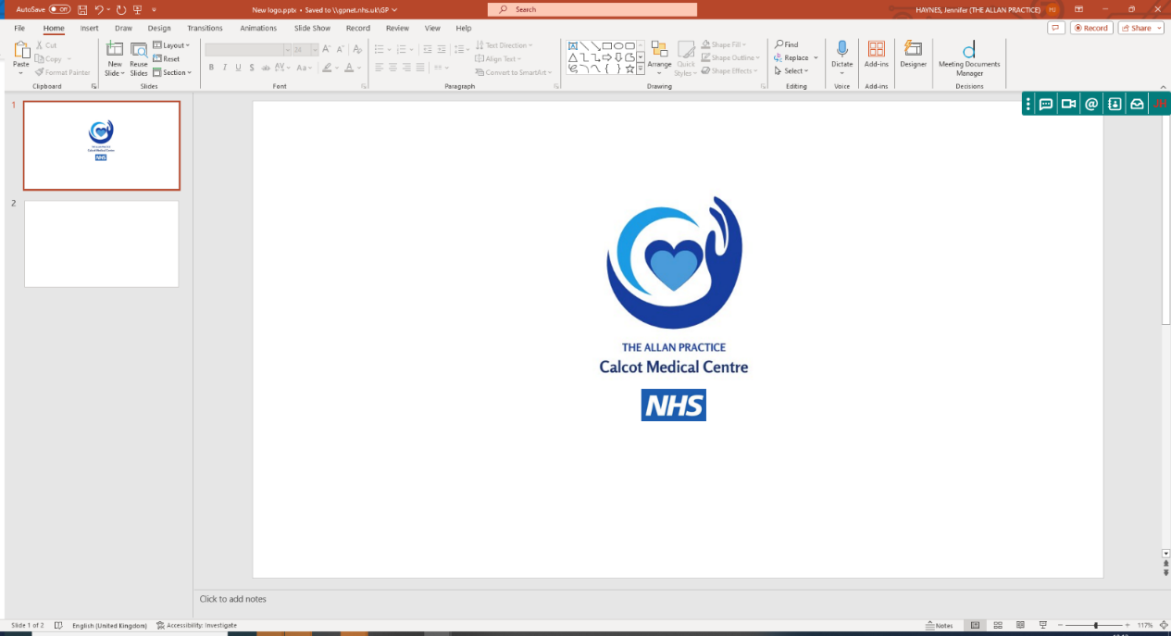
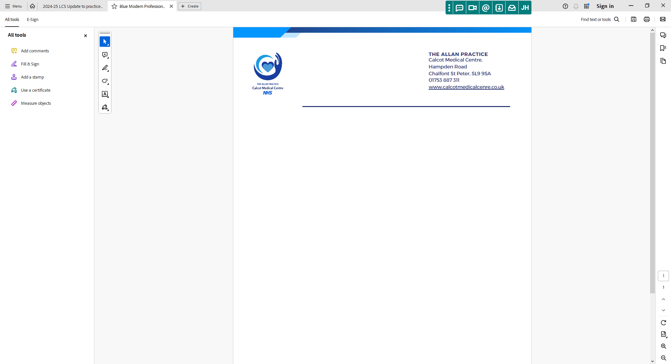

THE ALLAN PRACTICE
Calcot Medical Centre
Hampden Road
Chalfont St Peter, SL9 9SA
01753 887311
www.calcotmedicalcentre.co.uk

Calcot Medical Centre Car Park
Frequently asked questions
I’m a patient at The Hall Practice, where can I park?
You can park in the purple bays at the top of the car park or there is 1-hour free parking in Chalfont and Gerrards Cross Hospital which is across the road.
I’m an Allan Practice Patient but having blood tests at The Hall Practice, can I park in your car park?
If you are attending The Hall Practice you will need to park either in their purple bays at the top of the car park or in Chalfont and Gerrards Cross Hospital car park across the road as you are not attending this practice.
I want to drop my prescription off at the weekend when the practice is closed and won’t be able to register my number plate?
All cars are given a 5-minute grace period which should give enough time to drop off your prescription.
I’m disabled and have parked in the Calcot Medical Centre disabled bays, but I am visiting The Hall Practice
You will need to park in The Hall Practice disabled bays or across the road. The Calcot Medical Centre parking bays are just for patients and visitors attending Calcot Medical Centre
I’m a Hall Practice Patient but there is nowhere for me to park
Please speak to the staff at the Hall Practice and they can advise you where you can park
Why are you enforcing this new system
We are aware of recent difficulties some of our patients have had with parking at our practice, we have observed people using the car park when visiting local shops or other businesses. The ANPR system will deter unauthorised use of the car park and improve parking for everyone visiting Calcot Medical Centre. The Allan practice can only be responsible for those attending Calcot Medical Centre.

I’m dropping someone off, can I sit in the car and wait for them.
If you are dropping someone off and waiting for them, please make sure you register your number plate on the tablet inside the practice.
How long can I park in Chalfont and Gerrards Cross Hospital car park
You can park for free for 1 hour in Chalfont and Gerrards Cross Hospital, but you must get a ticket from the machine for this.
I’m just popping next door and have parked in your car park
If you are not attending Calcot Medical Centre, you will need to park in The Hall Practice Car Park or in Chalfont and Gerrards Cross Hospital car park which is across the road. The Calcot Medical Centre car park is for patients and visitors attending this practice only.
Both practices have always shared the car park – why the change?
Each practice is independent and has its own designated parking areas. Both practices used to be located in the Calcot Medical Centre building. In June 2023, The Hall Practice moved out of the Calcot Medical Centre and into the building next door, where they now have their own designated spaces (purple bays). The remaining spaces in the Calcot Medical Centre are reserved for its patients and visitors. The Allan Practice now hold sole liability and responsibility for managing and maintaining the Calcot Medical Centre car park.
I’m an Allan Practice Patient but attending a 2-hour appointment at the hospital so I’ve parked in your car park
If you are not attending the Calcot Medical Centre, you cannot park your car here. Chalfont and Gerrards Cross Hospital provides 1 hour of free parking.
I’m just going to the dentist up the road, but it’s always been agreed I can park here whilst attending
If you are not attending the Calcot Medical Centre, you cannot park your car here. The hospital provides 1 hour of free parking.
I’ve received a parking ticket who do I complain to?
Please contact the Parking Management Company direct, we are unable to reverse parking charge notices.
I’m visiting the Calcot Medical Centre but the car park is full, can I park in the purple bays?
The purple bays are for patients and visitors attending The Hall Practice only. If our car park is full, please park in the Chalfont and Gerrards Cross Hospital car park which provides 1 hour of free parking.

